# **Python Lists**

**Lists** are just like dynamically sized arrays, declared in other languages (vector in C++ and ArrayList in Java). Lists need not be homogeneous always which makes it the most powerful tool in Python. A single list may contain DataTypes like Integers, Strings, as well as Objects. Lists are mutable, and hence, they can be altered even after their creation.

Lists in Python are ordered and have a definite count. The elements in a list are indexed according to a definite sequence and the indexing of a list is done with 0 being the first index. Each element in the list has its definite place in the list, which allows duplication of elements in the list, with each element having its own distinct place and credibility.

**Note-** Lists are a useful tool for preserving a sequence of data and further iterating over it.

***Table of content:***

* [*Creating a List*](https://www.geeksforgeeks.org/python-list/#cl)
* [*Knowing the size of List*](https://www.geeksforgeeks.org/python-list/#ksl)
* [*Adding Elements to a List:*](https://www.geeksforgeeks.org/python-list/#ael)
  + [*Using append() method*](https://www.geeksforgeeks.org/python-list/#uam)
  + [*Using insert() method*](https://www.geeksforgeeks.org/python-list/#uim)
  + [*Using extend() method*](https://www.geeksforgeeks.org/python-list/#uem)
* [*Accessing elements from the List*](https://www.geeksforgeeks.org/python-list/#ael)
* [*Removing Elements from the List:*](https://www.geeksforgeeks.org/python-list/#rel)
  + [*Using remove() method*](https://www.geeksforgeeks.org/python-list/#urm)
  + [*Using pop() method*](https://www.geeksforgeeks.org/python-list/#upm)
* [*Slicing of a List*](https://www.geeksforgeeks.org/python-list/#sl)
* [*List Comprehension*](https://www.geeksforgeeks.org/python-list/#lc)
* *Operations on List*
* *List Methods*

## **Creating a List**

Lists in Python can be created by just placing the sequence inside the square brackets[]. Unlike Sets, a list doesn’t need a built-in function for the creation of a list.

**Note –** Unlike Sets, the list may contain mutable elements.

* Python3

| # Python program to demonstrate  # Creation of List    # Creating a List  List = []  print("Blank List: ")  print(List)    # Creating a List of numbers  List = [10, 20, 14]  print("\nList of numbers: ")  print(List)    # Creating a List of strings and accessing  # using index  List = ["Geeks", "For", "Geeks"]  print("\nList Items: ")  print(List[0])  print(List[2])    # Creating a Multi-Dimensional List  # (By Nesting a list inside a List)  List = [['Geeks', 'For'] , ['Geeks']]  print("\nMulti-Dimensional List: ")  print(List) |
| --- |

**Output:**

Blank List:

[]

List of numbers:

[10, 20, 14]

List Items

Geeks

Geeks

Multi-Dimensional List:

[['Geeks', 'For'], ['Geeks']]

### **Creating a list with multiple distinct or duplicate elements**

A list may contain duplicate values with their distinct positions and hence, multiple distinct or duplicate values can be passed as a sequence at the time of list creation.

* Python3

| # Creating a List with  # the use of Numbers  # (Having duplicate values)  List = [1, 2, 4, 4, 3, 3, 3, 6, 5]  print("\nList with the use of Numbers: ")  print(List)    # Creating a List with  # mixed type of values  # (Having numbers and strings)  List = [1, 2, 'Geeks', 4, 'For', 6, 'Geeks']  print("\nList with the use of Mixed Values: ")  print(List) |
| --- |

**Output:**

List with the use of Numbers:

[1, 2, 4, 4, 3, 3, 3, 6, 5]

List with the use of Mixed Values:

[1, 2, 'Geeks', 4, 'For', 6, 'Geeks']

## **Knowing the size of List**

* Python3

| # Creating a List  List1 = []  print(len(List1))    # Creating a List of numbers  List2 = [10, 20, 14]  print(len(List2)) |
| --- |

**Output:**

0

3

## **Adding Elements to a List**

### **Using append() method**

Elements can be added to the List by using the built-in [**append()**](https://www.geeksforgeeks.org/list-methods-python/) function. Only one element at a time can be added to the list by using the append() method, for the addition of multiple elements with the append() method, loops are used. Tuples can also be added to the list with the use of the append method because tuples are immutable. Unlike Sets, Lists can also be added to the existing list with the use of the append() method.

* Python3

| # Python program to demonstrate  # Addition of elements in a List    # Creating a List  List = []  print("Initial blank List: ")  print(List)    # Addition of Elements  # in the List  List.append(1)  List.append(2)  List.append(4)  print("\nList after Addition of Three elements: ")  print(List)    # Adding elements to the List  # using Iterator  for i in range(1, 4):  List.append(i)  print("\nList after Addition of elements from 1-3: ")  print(List)    # Adding Tuples to the List  List.append((5, 6))  print("\nList after Addition of a Tuple: ")  print(List)    # Addition of List to a List  List2 = ['For', 'Geeks']  List.append(List2)  print("\nList after Addition of a List: ")  print(List) |
| --- |

**Output:**

Initial blank List:

[]

List after Addition of Three elements:

[1, 2, 4]

List after Addition of elements from 1-3:

[1, 2, 4, 1, 2, 3]

List after Addition of a Tuple:

[1, 2, 4, 1, 2, 3, (5, 6)]

List after Addition of a List:

[1, 2, 4, 1, 2, 3, (5, 6), ['For', 'Geeks']]

### **Using insert() method**

append() method only works for the addition of elements at the end of the List, for the addition of elements at the desired position, insert() method is used. Unlike append() which takes only one argument, the insert() method requires two arguments(position, value).

* Python3

| # Python program to demonstrate  # Addition of elements in a List    # Creating a List  List = [1,2,3,4]  print("Initial List: ")  print(List)    # Addition of Element at  # specific Position  # (using Insert Method)  List.insert(3, 12)  List.insert(0, 'Geeks')  print("\nList after performing Insert Operation: ")  print(List) |
| --- |

**Output:**

Initial List:

[1, 2, 3, 4]

List after performing Insert Operation:

['Geeks', 1, 2, 3, 12, 4]

--------X---------

The insert function inserts the element at a particular index and then reindexes the list accordingly.

### **Using extend() method**

Other than append() and insert() methods, there’s one more method for the Addition of elements, [**extend()**](https://www.geeksforgeeks.org/append-extend-python/), this method is used to add multiple elements at the same time at the end of the list.

**Note –** [append() and extend()](https://www.geeksforgeeks.org/append-extend-python/) methods can only add elements at the end.

* Python3

| # Python program to demonstrate  # Addition of elements in a List    # Creating a List  List = [1,2,3,4]  print("Initial List: ")  print(List)    # Addition of multiple elements  # to the List at the end  # (using Extend Method)  List.extend([8, 'Geeks', 'Always'])  print("\nList after performing Extend Operation: ")  print(List) |
| --- |

**Output:**

Initial List:

[1, 2, 3, 4]

List after performing Extend Operation:

[1, 2, 3, 4, 8, 'Geeks', 'Always']

---------X------------X-----------

**Using the ‘+’ operator to add elements and extend the list**

The ‘+’ operator can be used to extend the list and also add elements to the end of the list.

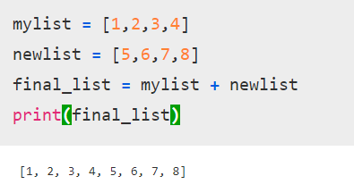

The above output is similar(not identical) to the given output below.

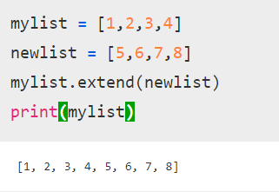

Similarly, if we want to add a single element, we can convert that element to a ‘one-element list’ and add it to the main list.

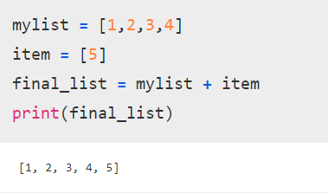

## **Using the ‘*’ operator in the List**

The ‘*’ operator can be used to create a repetitive list.

For example :

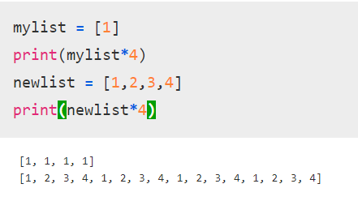

However, this technique should not be used in two-dimensional lists.

Explanation through an example below :

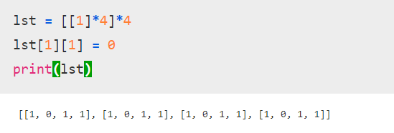

We created a two dimensional list of all 1-s’. However, when we want to modify only the 1st indexed element of the 1st indexed row, it changes the 1st indexed element of all the rows.

This is because python uses shallow lists and does not create 4 different integer objects, but just 1 integer object. Which results in all the indices of the array pointing to one integer.

-----------------------------------------

## 

## 

## **Accessing elements from the List**

In order to access the list items refer to the index number. Use the index operator [ ] to access an item in a list. The index must be an integer. Nested lists are accessed using nested indexing.

* Python3

| # Python program to demonstrate  # accessing of element from list    # Creating a List with  # the use of multiple values  List = ["Geeks", "For", "Geeks"]    # accessing a element from the  # list using index number  print("Accessing a element from the list")  print(List[0])  print(List[2])    # Creating a Multi-Dimensional List  # (By Nesting a list inside a List)  List = [['Geeks', 'For'] , ['Geeks']]    # accessing an element from the  # Multi-Dimensional List using  # index number  print("Accessing a element from a Multi-Dimensional list")  print(List[0][1])  print(List[1][0]) |
| --- |

**Output:**

Accessing a element from the list

Geeks

Geeks

Accessing a element from a Multi-Dimensional list

For

Geeks

### **Negative indexing**

In Python, negative sequence indexes represent positions from the end of the array. Instead of having to compute the offset as in List[len(List)-3], it is enough to just write List[-3]. Negative indexing means beginning from the end, -1 refers to the last item, -2 refers to the second-last item, etc.

* Python3

| List = [1, 2, 'Geeks', 4, 'For', 6, 'Geeks']    # accessing an element using  # negative indexing  print("Accessing element using negative indexing")    # print the last element of list  print(List[-1])    # print the third last element of list  print(List[-3]) |
| --- |

**Output:**

Accessing element using negative indexing

Geeks

For

## **Removing Elements from the List**

### **Using remove() method**

Elements can be removed from the List by using the built-in **remove()** function but an Error arises if the element doesn’t exist in the set. Remove() method only removes one element at a time, to remove a range of elements, the iterator is used. The remove() method removes the specified item.

**Note –** Remove method in List will only remove the first occurrence of the searched element.

* Python3

| # Python program to demonstrate  # Removal of elements in a List    # Creating a List  List = [1, 2, 3, 4, 5, 6,  7, 8, 9, 10, 11, 12]  print("Initial List: ")  print(List)    # Removing elements from List  # using Remove() method  List.remove(5)  List.remove(6)  print("\nList after Removal of two elements: ")  print(List)    # Removing elements from List  # using iterator method  for i in range(1, 5):  List.remove(i)  print("\nList after Removing a range of elements: ")  print(List) |
| --- |

**Output:**

Initial List:

[1, 2, 3, 4, 5, 6, 7, 8, 9, 10, 11, 12]

List after Removal of two elements:

[1, 2, 3, 4, 7, 8, 9, 10, 11, 12]

List after Removing a range of elements:

[7, 8, 9, 10, 11, 12]

### **Using pop() method**

Pop() function can also be used to remove and return an element from the set, but by default it removes only the last element of the set, to remove an element from a specific position of the List, the index of the element is passed as an argument to the pop() method.

* Python3

| List = [1,2,3,4,5]    # Removing element from the  # Set using the pop() method  List.pop()  print("\nList after popping an element: ")  print(List)    # Removing element at a  # specific location from the  # Set using the pop() method  List.pop(2)  print("\nList after popping a specific element: ")  print(List) |
| --- |

**Output:**

List after popping an element:

[1, 2, 3, 4]

List after popping a specific element:

[1, 2, 4]

---------X-----------------X

If we want to get the last element of the list and remove it as well, we will pass a variable along with the pop function.

Example :

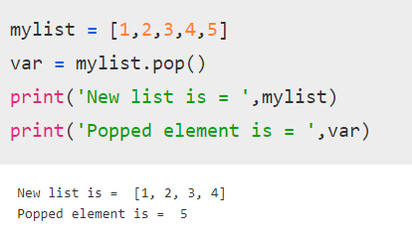

-----------------

## **Slicing of a List**

In Python List, there are multiple ways to print the whole List with all the elements, but to print a specific range of elements from the list, we use the Slice operation. Slice operation is performed on Lists with the use of a colon(:). To print elements from beginning to a range use [: Index], to print elements from end-use [:-Index], to print elements from specific Index till the end use [Index:], to print elements within a range, use [Start Index:End Index +1] and to print the whole List with the use of slicing operation, use [:]. Further, to print the whole List in reverse order, use [::-1].

**Note –** To print elements of List from rear-end, use Negative Indexes.

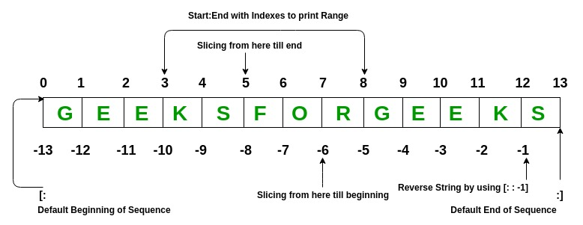

* Python3

| # Python program to demonstrate  # Removal of elements in a List    # Creating a List  List = ['G','E','E','K','S','F',  'O','R','G','E','E','K','S']  print("Initial List: ")  print(List)    # Print elements of a range  # using Slice operation  Sliced_List = List[3:8]  print("\nSlicing elements in a range 3-8: ")  print(Sliced_List)    # Print elements from a  # pre-defined point to end  Sliced_List = List[5:]  print("\nElements sliced from 5th "  "element till the end: ")  print(Sliced_List)    # Printing elements from  # beginning till end  Sliced_List = List[:]  print("\nPrinting all elements using slice operation: ")  print(Sliced_List) |
| --- |

**Output:**

Initial List:

['G', 'E', 'E', 'K', 'S', 'F', 'O', 'R', 'G', 'E', 'E', 'K', 'S']

Slicing elements in a range 3-8:

['K', 'S', 'F', 'O', 'R']

Elements sliced from 5th element till the end:

['F', 'O', 'R', 'G', 'E', 'E', 'K', 'S']

Printing all elements using slice operation:

['G', 'E', 'E', 'K', 'S', 'F', 'O', 'R', 'G', 'E', 'E', 'K', 'S']

### **Negative index List slicing**

* Python3

| # Creating a List  List = ['G','E','E','K','S','F',  'O','R','G','E','E','K','S']  print("Initial List: ")  print(List)    # Print elements from beginning  # to a pre-defined point using Slice  Sliced_List = List[:-6]  print("\nElements sliced till 6th element from last: ")  print(Sliced_List)    # Print elements of a range  # using negative index List slicing  Sliced_List = List[-6:-1]  print("\nElements sliced from index -6 to -1")  print(Sliced_List)    # Printing elements in reverse  # using Slice operation  Sliced_List = List[::-1]  print("\nPrinting List in reverse: ")  print(Sliced_List) |
| --- |

**Output:**

Initial List:

['G', 'E', 'E', 'K', 'S', 'F', 'O', 'R', 'G', 'E', 'E', 'K', 'S']

Elements sliced till 6th element from last:

['G', 'E', 'E', 'K', 'S', 'F', 'O']

Elements sliced from index -6 to -1

['R', 'G', 'E', 'E', 'K']

Printing List in reverse:

['S', 'K', 'E', 'E', 'G', 'R', 'O', 'F', 'S', 'K', 'E', 'E', 'G']

------------X------------X

If we are slicing a range of the list, then it is not necessary to give the correct final index. For example :

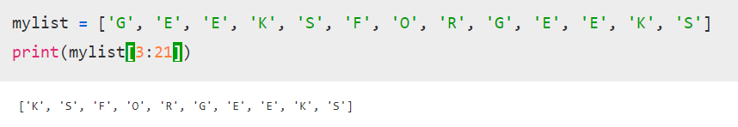

In this case, we entered a list index from 3 to 21. The list does not contain indices upto 21, so it will automatically assume the value till the maximum available index.

------------------------

## **List Comprehension**

**List comprehensions** are used for creating new lists from other iterables like tuples, strings, arrays, lists, etc.

A list comprehension consists of brackets containing the expression, which is executed for each element along with the for loop to iterate over each element.

**Syntax:**

*newList = [ expression(element) for element in oldList if condition ]*

**Example:**

* Python3

| # Python program to demonstrate list  # comprehension in Python    # below list contains square of all  # odd numbers from range 1 to 10  odd_square = [x ** 2 for x in range(1, 11) if x % 2 == 1]  print (odd_square) |
| --- |

**Output:**

[1, 9, 25, 49, 81]

For better understanding, the above code is similar to –

* Python3

| # for understanding, above generation is same as,  odd_square = []    for x in range(1, 11):  if x % 2 == 1:  odd_square.append(x**2)    print (odd_square) |
| --- |

**Output:**

[1, 9, 25, 49, 81]

## **Operations on List**

* [Find length of list](https://www.geeksforgeeks.org/python-ways-to-find-length-of-list/)
* The len() function gives the length of the list.

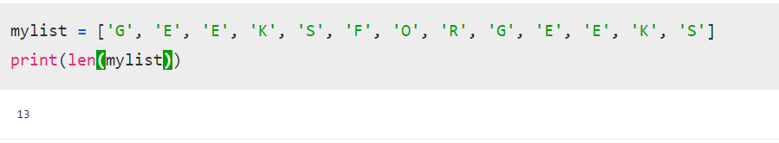

* [Concatenating two lists in Python](https://www.geeksforgeeks.org/python-ways-to-concatenate-two-lists/)

-Explained through ‘+’ operator and the extend function above.

## **List Methods**

| Function | Description |
| --- | --- |
| [Append()](https://www.geeksforgeeks.org/append-extend-python/) | Add an element to the end of the list |
| [Extend()](https://www.geeksforgeeks.org/append-extend-python/) | Add all elements of a list to another list |
| [Insert()](https://www.geeksforgeeks.org/list-methods-in-python-set-2-del-remove-sort-insert-pop-extend/) | Insert an item at the defined index |
| [Remove()](https://www.geeksforgeeks.org/list-methods-in-python-set-2-del-remove-sort-insert-pop-extend/) | Removes an item from the list |
| [Pop()](https://www.geeksforgeeks.org/list-methods-in-python-set-2-del-remove-sort-insert-pop-extend/) | Removes and returns an element at the given index |
| [Clear()](https://www.geeksforgeeks.org/list-methods-in-python-set-2-del-remove-sort-insert-pop-extend/) | Removes all items from the list |
| [Index()](https://www.geeksforgeeks.org/python-list-index/) | Returns the index of the first matched item |
| [Count()](https://www.geeksforgeeks.org/python-list-function-count/) | Returns the count of the number of items passed as an argument |
| [Sort()](https://www.geeksforgeeks.org/sort-in-python/) | Sort items in a list in ascending order |
| [Reverse()](https://www.geeksforgeeks.org/list-methods-in-python-set-2-del-remove-sort-insert-pop-extend/) | Reverse the order of items in the list |
| [copy()](https://www.geeksforgeeks.org/python-list-copy-method/) | Returns a copy of the list |

### **Built-in functions with List**

| Function | Description |
| --- | --- |
| [reduce()](https://www.geeksforgeeks.org/reduce-in-python/) | apply a particular function passed in its argument to all of the list elements stores the intermediate result and only returns the final summation value |
| [sum()](https://www.geeksforgeeks.org/sum-function-python/) | Sums up the numbers in the list |
| [ord()](https://www.geeksforgeeks.org/ord-function-python/) | Returns an integer representing the Unicode code point of the given Unicode character |
| [cmp()](https://www.geeksforgeeks.org/python-2-number-cmplist-method/) | This function returns 1 if the first list is “greater” than the second list |
| max() | return maximum element of a given list |
| min() | return minimum element of a given list |
| [all()](https://www.geeksforgeeks.org/any-all-in-python/) | Returns true if all element is true or if the list is empty |
| [any()](https://www.geeksforgeeks.org/any-all-in-python/) | return true if any element of the list is true. if the list is empty, return false |
| len() | Returns length of the list or size of the list |
| [enumerate()](https://www.geeksforgeeks.org/enumerate-in-python/) | Returns enumerate object of the list |
| accumulate() | apply a particular function passed in its argument to all of the list elements returns a list containing the intermediate results |
| [filter()](https://www.geeksforgeeks.org/filter-in-python/) | tests if each element of a list is true or not |
| [map()](https://www.geeksforgeeks.org/python-map-function/) | returns a list of the results after applying the given function to each item of a given iterable |
| [lambda()](https://www.geeksforgeeks.org/python-lambda-anonymous-functions-filter-map-reduce/) | This function can have any number of arguments but only one expression, which is evaluated and returned. |

### [Recent articles on Lists](https://www.geeksforgeeks.org/tag/python-list/)

***More videos on Python Lists:***

[*Python List – Set 2*](https://youtu.be/1Ej7ry6jacg)

### **More on Python List –**

* [Creating a 3D List](https://www.geeksforgeeks.org/python-creating-3d-list/)
* [Iterate over a list in Python](https://www.geeksforgeeks.org/iterate-over-a-list-in-python/)
* [Iterate over multiple lists simultaneously](https://www.geeksforgeeks.org/python-iterate-multiple-lists-simultaneously/)
* [Internal working of list in Python](https://www.geeksforgeeks.org/internal-working-of-list-in-python/)
* [Python Slicing](https://www.geeksforgeeks.org/python-slicing-reverse-array-groups-given-size/)
* [Python List Comprehensions vs Generator Expressions](https://www.geeksforgeeks.org/python-list-comprehensions-vs-generator-expressions/)
* List Methods in Python – [Set 1](https://www.geeksforgeeks.org/list-methods-in-python-set-1-in-not-in-len-min-max/) [Set 2](https://www.geeksforgeeks.org/list-methods-python/)
* [Lambda expression and filter function](https://www.geeksforgeeks.org/intersection-two-arrays-python-lambda-expression-filter-function/)

**Useful Links:**

* [Recent Articles on Python List](https://www.geeksforgeeks.org/tag/python-list/)
* [Python Tutorials](https://www.geeksforgeeks.org/python-programming-language/)
* Python Output Programs in List: [Set 6](https://www.geeksforgeeks.org/output-python-program-set-6/), [Set 11](https://www.geeksforgeeks.org/output-python-program-set-11lists/), [Set 12](https://www.geeksforgeeks.org/output-python-program-set-12lists-tuples/), [Set 13](https://www.geeksforgeeks.org/output-python-program-set-13lists-tuples/)
* [Multiple Choice Questions](https://www.geeksforgeeks.org/python-multiple-choice-questions/)
* [All articles in Python Category](https://www.geeksforgeeks.org/category/python/)